Week 4

Q.1). Create a list of numbers and find the sum and average of the list.

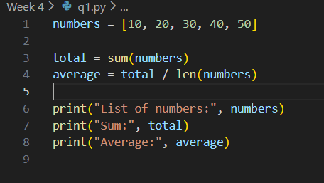
Output
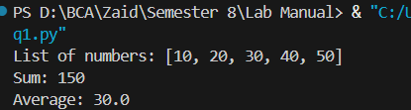
Q.2). Write a function to check whether a given string is a palindrome.
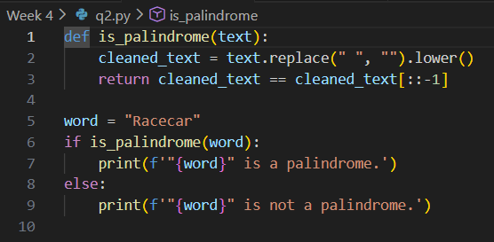
Output
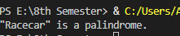
Q.3). Create a dictionary of student names and marks. Display students scoring above 75.
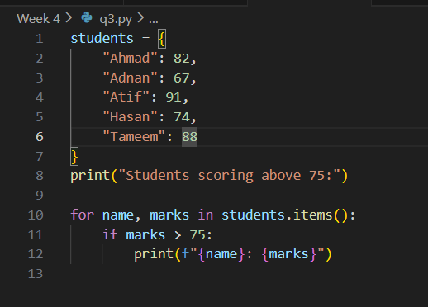
Output
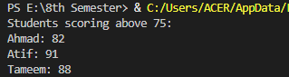

Q.4). Write a program to sort a list in ascending and descending order.
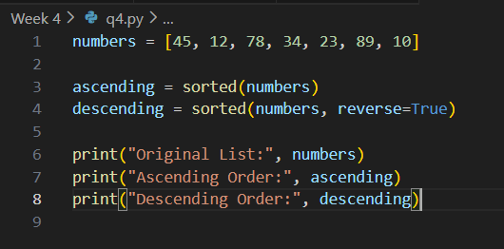
Output
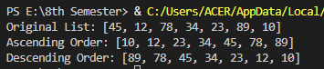
Q.5). Write HTML code to generate the following output:
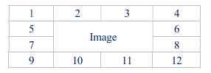
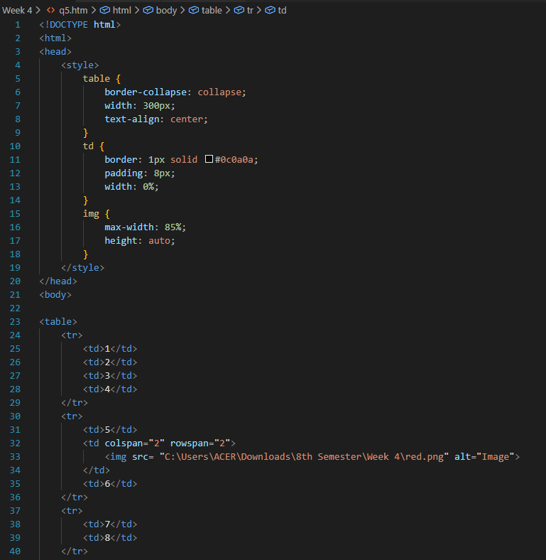
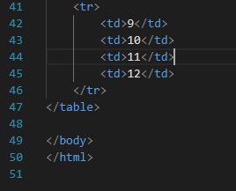
Output
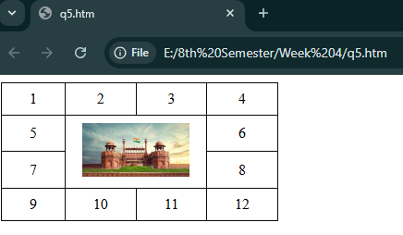
Q.6). Write an HTML code to develop a Web page having two frames that divide the Web page into two equal rows and then divide the second row into two equal columns, then fill each frame with a different background color.
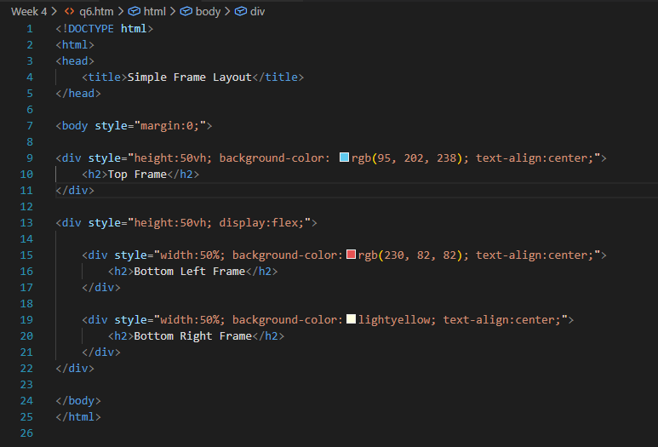
Output
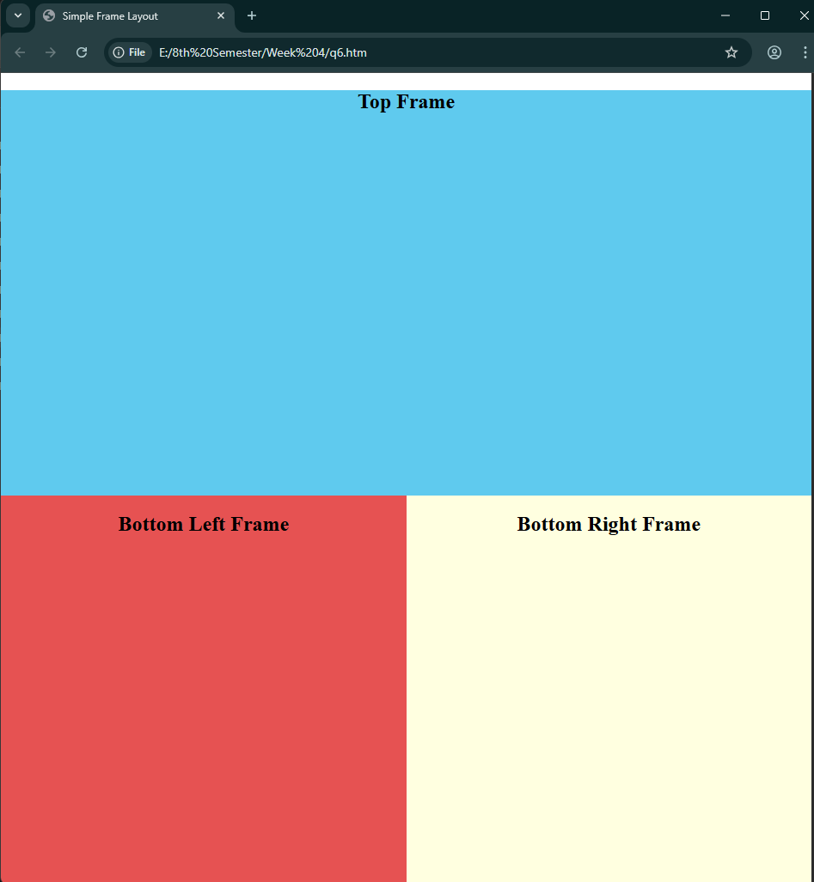
Q.7). Design an HTML Page having 3 images placed in the following format. (Hint: Figure 1)
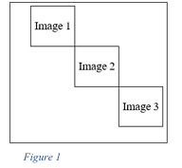
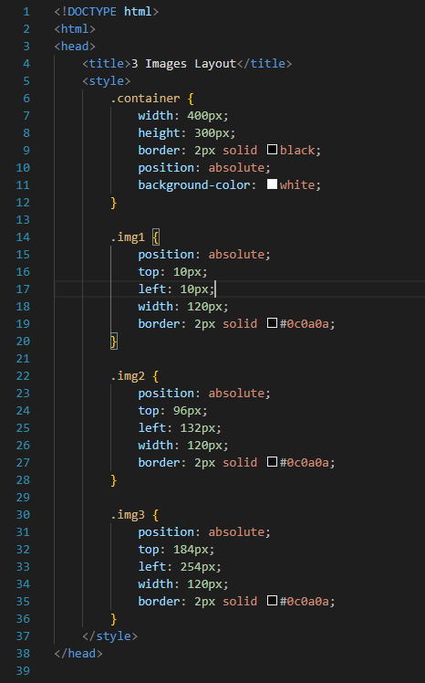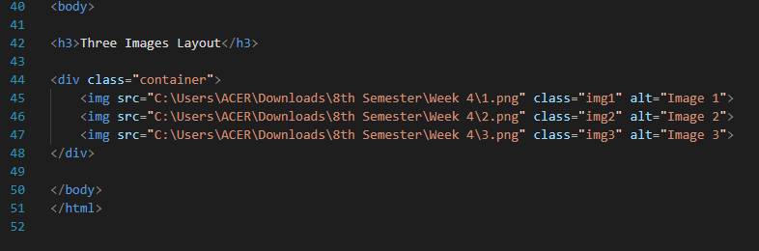
Output
